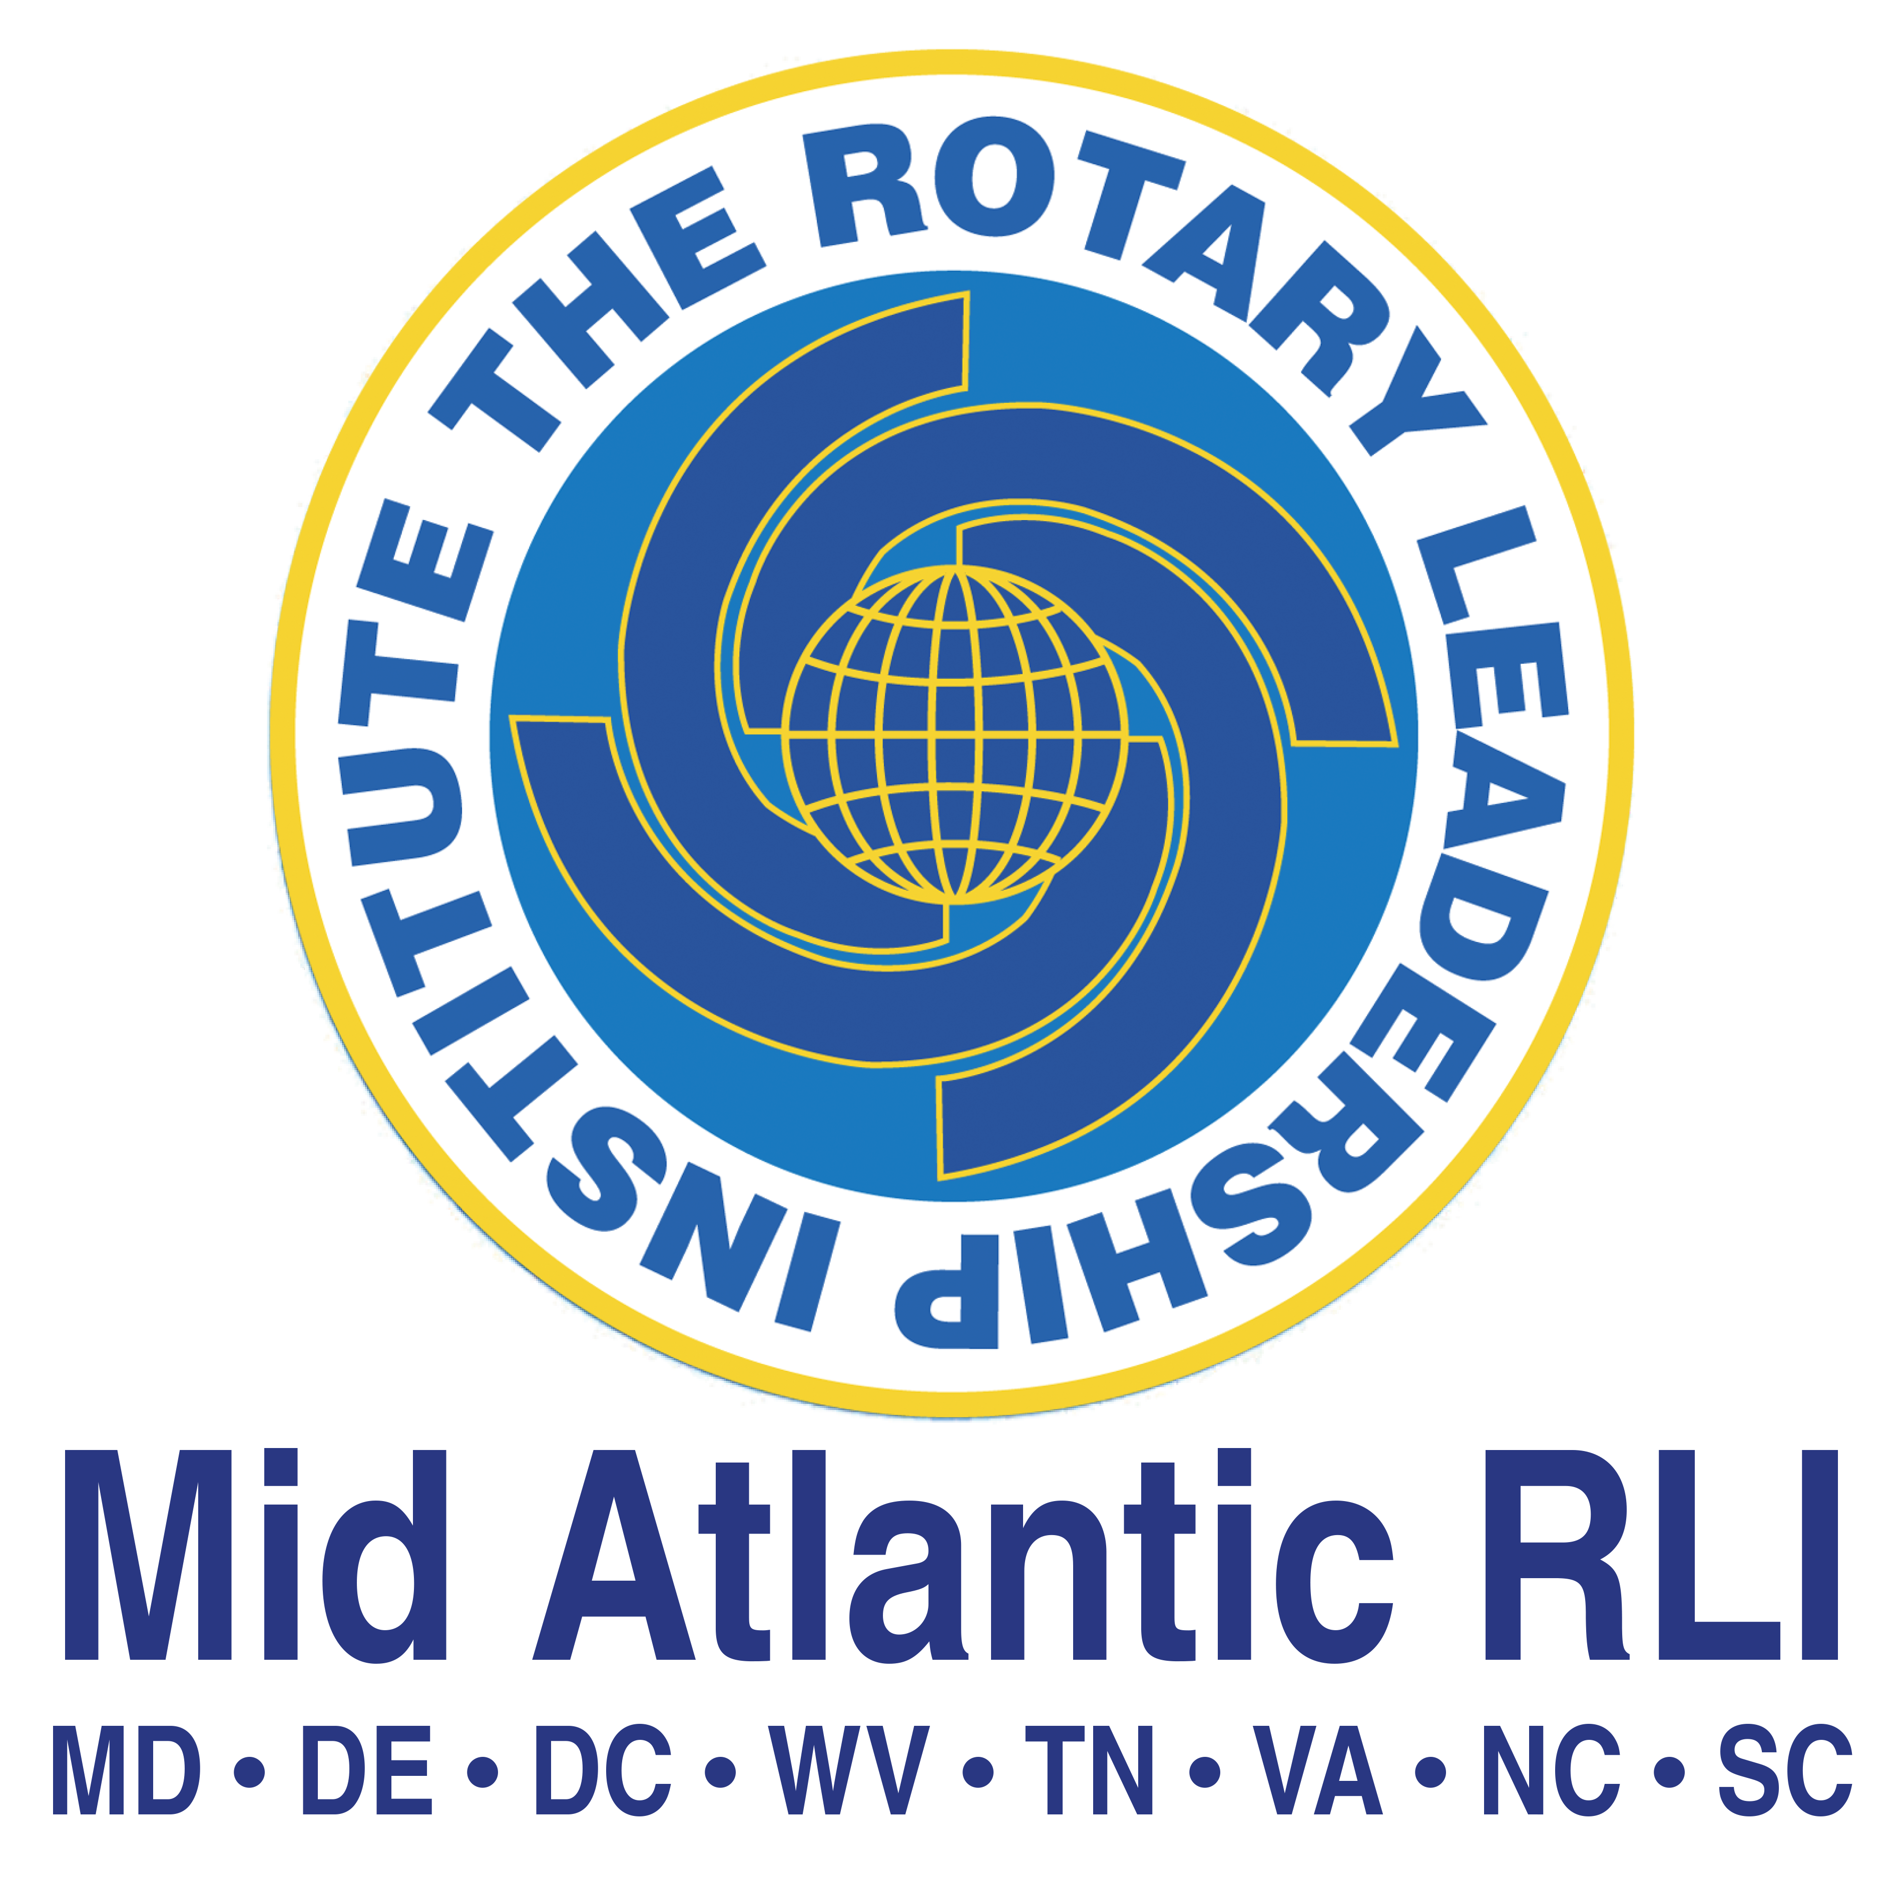

Mid-Atlantic Rotary Leadership Institute
(MARLI) Board of Directors Meeting
July 12, 2024

Welcome
Meeting called to order by outgoing Chair, Marcia Scheideman, at: 10:10am. The 2024-2025 MARLI Board of Directors/Leadership Team was installed by the outgoing board. The gavel was officially passed to Sean Sawyer, Mid-Atlantic RLI Board Chair.

District 7600 District Governor Joy Kline welcomed the group to District 7600, recognizing members of the leadership team in District 7600, and encouraged us to “Find Joy in the Journey”

Roll was taken by the Secretary and a quorum was determined with 13 voting members present.
Board members Present:

Name | District | Present
Sean Sawyer | 7545 | X
Chris Stevenson | 7730 | X
Marcia Scheideman | 7680 | X
Barbara Dresser | 7730 | X
Ralph Menzel | 7610 | X
Roger Harrell | 7630 | X
Bevin Wall | 7730
Tom Ledbetter | 7770 | X
Debbie Scott | 7690 | X
Patrick Rooney | 7710 | X
Rod Funderburk | 7770 | X
Barbara Dresser | 7730 | X
Tarek Moneir | 7570 | X
SuAnne Hardee Bryant | 7600 | X
Lin Kelly | 7730 | X
Eric Adamson | 7570
Member Representatives and Guests
Numerous Regional Coordinators, District Chairs and guests attended due to plan to attend faculty update to follow

Welcome and Introductions by Chair – Sean Sawyer
Chair Sean distributed Mid-Atlantic RLI flowchart and explained rationale behind placement of positions. Bea agreed to put it on the website.

Chris Stevenson distributed minutes. Recommendation made to dispense with the reading of the minutes. Chris called upon Sean to entertain a motion to approve the minutes. SuAnne Bryant moved, and Tarek Moneir seconded the motion. Motion carried.

Treasurer Report
- Barbara Dresser, Treasurer gave report
- Presented and explained the new budget. Encouraged districts to add participation through promotion of RLI at District and Zone events to increase registration and thereby income. Barbara requested that board members review and provide input.
- The organization was realizing a $226 increase in income due to switching of our investment instruments
- Current statement
  - Checking - $54,044
  - Simple Saving - $12,188.83
  - DC - $50,000
  - TOTAL - $116,233.33
  - Current Outstanding Checks - $3754.44
- Sean will be added to financial access.
- District Chairs and Regional Coordinator need to follow the reimbursement and refund policy when submitting expenses.

PI Committee
- Bea described changes in the website and organization of site. It is an ongoing process.
- Requested input from group
- Presented new Step and Repeat and Table Covering for use at regional and zone meetings
- Promoted status of Alumni Group and its value to the organization
- Suggestion to offer Rotaractors a reduced price for RLI.

Faculty Trainer
- Paddy presented a revised process for onboarding graduates to NFT. It will be a multi-site process. Standard forms will be provided to the District Chair. Report provided. Committee recommendation for onboarding process to NFT passed and will be implemented over the next year as support materials are developed and approved.
- In last year an ad hoc committee engaged in a review and update of participant materials and their corresponding faculty guides. All sessions have been or are in the process of being reviewed by the committee. Expect this review to be completed by 8-31. Will then be reviewed professionally for errors and completed by January meeting in Kannapolis.
- Much of the work involved on these materials has been completed by Georgia Oakes and her work was recognized by many of the members
- Virtual Session – is a topic that needs to be revisited and adjustments made to accommodate members of the eClubs and others that are hindered by the need to travel to sessions and to be more inclusive

Bylaws Committee
- Rod Funderburk presented revised bylaws and explained changes. These were distributed to the 2023-2024 voting members in a 45-day window as required. Motion passed.
Reimbursement Policy
- Rod distributed recommended changes to policy. Discussion ensued.
- Exceptions were discussed with no decisions made. Policy changes were tabled until the next meeting.

Nominating Committee
- Chris called for anyone interested in participating in the nominating committee to contact him.
- Current Board with terms
LEADERSHIP:
- Sean Sawyer, Chair 2024-2026
- Chris Stevenson, Vice Chair 2024-2026
EX-OFFICIO
- Marcia Scheideman, Immediate Past-Chair and Secretary 2024-2026
- Patrick Rooney, Faculty Trainer 2024-2025
- Bea Carson, PI Chair 2024-2025
- Barbara Dresser, Treasurer 2024-2025
DIRECTORS
- Roger Harrell 2024-2027
- Ralph Menzel 2024-2027
- Debbie Scott 2024-2027
- Tom Ledbetter 2024-2026
- SuAnne Bryant 2024-2026
- OPEN POSITION 2024-2026
- Lin Kelly 2023-2025
- Tarek Moneir 2022-2025
- OPEN POSITION 2022-2025

Legal IRS Issue
- SuAnne announced that she is on top of the tax issue regarding IRS status. The requisite forms have been submitted to the IRS.

Old Business
- Name tags distributed; will be reordered due to spelling error
- Marcia will provide Barbara with new list that reflects most current faculty status
- Badges with additional roles (Regional Coordinator; District Chair) yet to be ordered
New Business
- Allison Burkett introduced as new Regional Coordinator for Western North Carolina
- Renee Stubbs and Julie Larson proposed a reduced cost for Part 1 to encourage registration.

Meeting Adjourned – 12:11pm

Next Quarterly Board Meeting – Wednesday October 2, 2024 @ 5:30pm

Annual Meeting Winter Faculty Update
January 10-11, 2025, Rowan Cabarrus Community College, Kannapolis, NC

